**Part 12 – Absolute Value Inequalities**

**Example.** What x-values satisfy

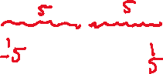

**Number Line:**

**Inequality:**



**Interval Notation:**



**Example.** What x-values satisfy



**Number line:**



**Inequality:**



**Interval notation:**



**Example.** Solve

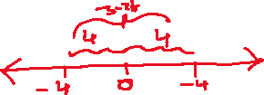

**Example.** Solve

